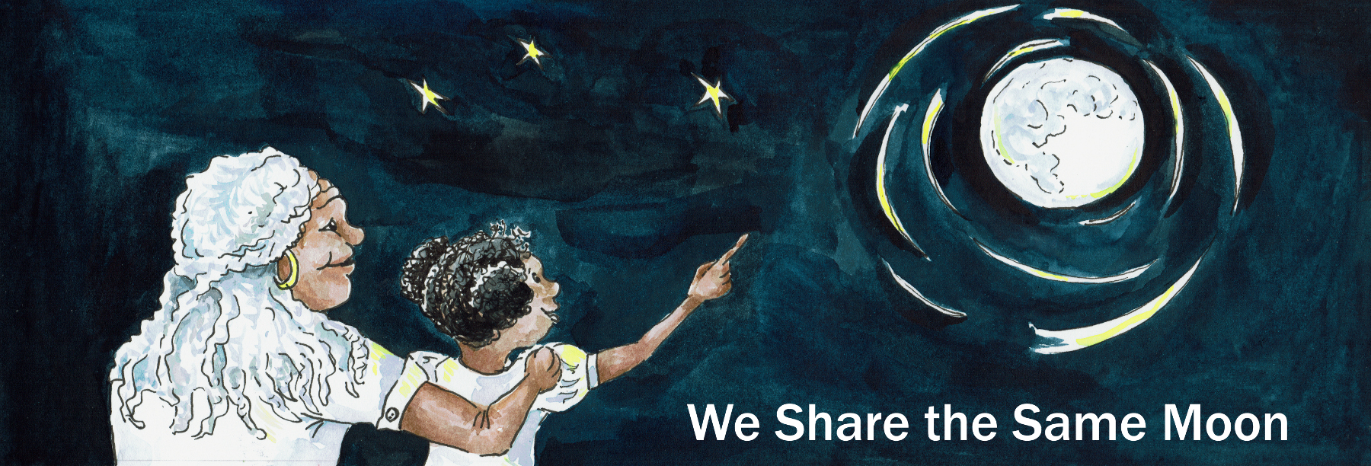
Suggested Age Range: 10 - 11 years; 11 - 12 years; 12 - 13 years; 13 - 14 years; Adult;
UK Curriculum: Key Stage Two;
Suggested UK Year Group: Year Five
UK Primary Curriculum Link: Earth and Space
Science Subject: Solar System; Stars
Science Questions: What are planets? What are Stars?
Suggested Science Activity: Solar System on a String
Children with SEND: Use to boost comprehension of science vocabulary
EAL children: For confident older learners
Country of Origin: First Nations of America
Source: The Star Husband by Lynn Moroney

NB There are many variants of this tale, but the Morning Star mentioned in this retelling, is not a star, but the planet Venus, which is often called the Morning Star.

Imagine, that there is a prairie that stretches as far as the eye can see ….
With tall, golden grass that rustles gently in the breeze.
And above the grass, there is the endless blue of the sky.
And in the middle of that prairie, there is a circle of tents.
And in the middle of circle of tents, there is a fire.
And sat round the fire, are the people, the first people of America.
And they are talking, laughing, singing, drumming around the fire as the flames dance into the sky.

But …

Three girls turn and walk away from the light, and into the long, long, grass and soon the fire disappears from sight, and sound.
And they look up at the stars.
There is no Moon, the sky is dark, and there are no clouds in the sky.
And the stars are shining so bright, they almost dazzle.
“Look! cries one girl “There’s a blue one! And there’s a yellow one”
“Look!” cries another “There is a star falling from the sky!”
They look and wonder at the patterns that the stars seem to make as they move across the sky.
But one star does not move. And shines brighter than all the rest.
The star we call “The Morning Star”.
“That one!” cries the third girl. “That is the star I am going to marry!”
And her friends laugh at her and tease her for her wish.
They all know it’s a preposterous idea, for no-one can marry a star.
And slowly, they turn and the three girls walk away from the stars and back to the fire.
Still laughing gently, they walk towards the light.

But the next night …

The fire is lit, the people gather, they talk, they sing, they drum around the fire. But, one girl does not. She turns and walks into the prairie, into the long, long grass, away from her people. And she looks up at the sky to see the Morning Star, the Star that she said she would marry. But it isn’t there.

And then she realises there is someone else in the long, long grass, hidden in the shadow.“Who is there?” she asks.
“It is I, the Morning Star. The star you said you wanted to marry.”
She turns towards the voice and a figure steps out from the grass and looks at her.She sees a tall man with blue-black long hair, braided into a plait with an eagle feather tied into his hair.
“Was it true, what you said last night?’ said the Morning Star.
“Will you marry me and live amongst the stars?”
And she finds herself nodding. “Yes it is true” she says.
“I will marry you and live with your people in the sky”

And so he takes the feather from his hair and hands it to her.
And when she takes hold of the feather, she finds herself, rising, rising into the sky.
And she laughs with joy as she grabs the hands of her future husband.
And she doesn’t look back, but turns her face to the sky.

And then they arrive in the land of the sky-people and there is the Sun, her father-in-law and the Moon, her mother-in-law, in human form, and they come to meet her, hands outstretched in welcome.
And she takes their hands and smiles with joy at her new home.
And she doesn’t look back. And she doesn’t look down.

And time passes and the two are married.
And Sun and Moon, they make a home for her in the sky.
It is identical to the one she has left. Almost.
Moon shows her what to eat and gives her a digging stick and a basket so she can gather the fruit and the roots and the berries.
And it is almost like being at home. Almost.
The fruit and the roots and the berries are almost the same. Save for one.
“This root you must not eat” says Moon.
The forbidden root, it looks almost like a prairie turnip.
And at home, prairie turnips are good to eat.
But she nods, knowing that not everything is as it seems.

Time passes, they build a home together and finally they have a baby.
And everyone rejoices. Almost. Save for the young girl.
For she finds herself staring into her baby’s brown eyes.
And they look so like her fathers eyes.
And in her mind’s eye she sees him, looking up the sky.
Tears pouring silently down his face, as he mourns for his lost child.
And she wishes, oh how she wishes, she could show him, her father, the baby, her child.

And she finds herself spending more and more time by herself.
She is listless, She does little bar feed herself and the baby.

One day, she wanders off, far from the camp, as if in a dream.
And when she comes to, the baby is crying.
He is hungry, desperate for food.
She looks around her, but there is no food.
Far from new home, she forgot to bring anything.

She looks around her. And there is a root growing, turnip-shaped.
She reaches, but then she remembers.
“This root is not for you” her mother in law had said.
But, the baby is crying and there is no other food.
She puts down the baby, takes hold of the root and pulls.
And, as it leaves the ground, there is a small crack of sound.
And when she looks at where the root has been, there is a hole through the sky to the Earth below. And she lies down and looks through the hole.

And she sees …

The prairie below, stretching as far as the eye can see.
And in the middle of the prairie, she sees a fire and a circle of tents.
And a man standing away from the camp, looking up the sky.
And she knows who this man is! Her father!
“I want to go home!” she cries. But she cannot.
She stumbles back to camp.
And sits in silence with her people around the fire.

“Whats the matter? asked Moon.
And then the Moon, looks at her stricken face, knows what she has seen.
“Did you take the root, that you were told not to touch?”
“Yes" she nods.
“Then you can no longer stay here” says the Moon.
“This is no longer your home. You must return to Earth”.
The girl is over-joyed. This is what she had wanted!
But, what about her son? Where does he belong?

“That is up to you” said the Moon “You may take the child with you, if you wish. But if you wish him to stay on Earth, you must bind him to you. Hold him in your arms for fifteen nights and fifteen days. Do not let him touch the ground. If your mother and father holds him for you, they too must not let him touch the ground. For if you do - he will leave the Earth and never return.”

The girl nods her agreement. Holding the baby, she turns to her husband.
There are no words she can say, so she says nothing.
She takes the eagle feather from her hair and hands it back to him.
And immediately she starts to sink, down and down and down, faster and faster.
She finds herself standing back on the Earth, in the middle of the prairie.
And there is a circle of tents, with a fire and running from the fire towards her, is her father.
And he runs and runs. And grabs and holds them both tight, so very tight.
And when her father takes hold of the baby and looks into his eyes, she knows, she knows that she has done right. This is her place, her home.

But …

If the Earth is to be her son’s home, then she most do as she was told.
And for fifteen nights and fourteen days, she does.
And then on the last day, there is just her, and her mother and her son, wrapped in bundle of blankets together around the fire.
It is a cold day, and the fire is getting low and the baby starts to grizzle.
She gets up to go and find some more wood for the fire.
She hands the bundle of blankets to her mother, who takes hold of the bundle tightly, for the mother knows that the baby must not touch the ground.

But …

The fire is getting dangerously low and there is frost in the air.
She holds the babe in one hand and stretches for remaining wood,
but it is just out of reach.
So, she puts the baby down, and reaches towards the wood.
And one tiny questing hands comes out of the bundle of blankets to touch…
"No, no, no, no, no you don’t!!” The mother snatches the bundle of blankets up in her arms and carries him closer to the fire. They curl up together.
The daughter comes home, clutching a bundle of sticks for the fire.
Her mother hands her the baby.

But …

The bundle of the blankets seems strangely light.
She tears open the blankets and sees - nothing but a speck of stardust.
She looks at her mother.
“No, no, no, no, no, I didn’t!” Her mother whispers.
But her daughter nods “Yes, you did.”

That night, there is a fire, and around the fire the people gather.
They talk, they laugh, they sing, they drum, as the firelight dances towards the sky.

Save for one. One young woman, who turns away from the light.
And walks into the darkness of the prairie and looks up at the sky.
And she sees a new star shining there, her son.

Copyright Cassandra Wye May 2019

